1>**LAB EXERCISE: - Write a simple "Hello World" program in two different programming languages of your choice. Compare the structure and syntax.**

=>C language:

#include<stdio.h>

Main ()

{printf(“Hello World”); }

-> Python:

Print(“Hello world”)

**THEORY EXERCISE:** **- Q) Explain in your own words what a program is and how it functions.**

->A **program** is a set of instructions which is written in a specific manner that a computer can understand and execute. These instructions tell the computer what tasks to perform and in what order.

* How it function

->input

->output

->storage and memory

->processing

2>**THEORY EXERCISE:** -Q) **what is a key steps involved in the programing process?**

->The key steps involved in the programing process which makes your program or website more effective are:-

* **Planning and Design which means make your problem short so that you can easily manage to handle it.**
* **Codding which means write your code in the specific language to implement your own design.**
* **Testing which means after you complete your codding work test your program and solve the bugs if there are in your problems.**
* **Deployment means make your program / work available to all the users by hosting in server or publishing in World Wide Web.**
* **Maintenance and updates which means try to know your bugs after you deploy your program.**

3>**THEORY EXERCISE: -Q) What are the main difference between high-level and low-level programing language?**

->Difference between high-level and low-level programing language is:

* ABSTRACTION: In high level language it provides high level of abstraction whereas, in low level language it provides a low level of abstraction.
* PERFORMANCE: In high level language its performance is love whereas, in low level language its performance is high.
* EXECUTION: In high level language Require compilers or interpreters to convert code into machine language whereas, low level language is directly executed by the computer.

4>**LAB EXERCISE**: **-Research and create a diagram of how data is transmitted from a client to a server over the internet**

**=>** 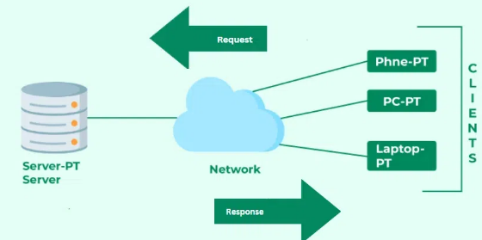

**THEORY EXERCISE**:-**Q) Describe the roles of the Clint and server in web communication.**

-> Roles of the Clint and server in the web communications are:

* Roles of clients:

1) Request initiation

2) User interaction

3) Rendering

4) Stateless Nature

* Roles of server:

1) Request handling

2) Data Processing

5> **LAB EXERCISE: Design a simple HTTP client-server communication in any language.**

**=>**

**THEORY EXERCISE**: -**Q) Explain the function of the TCP/IP model and its layers.**

=>Function of TCP:

* Facilitates Communication:

-Defines how data should be transmitted between devices.

* Scalability:

-Supports networks of various sizes, from small local networks to the global internet.

* Breaks Down Complexity:

-Divides the communication process into layers, where each layer has specific responsibilities.

=>layers of TCP:

* Application layer:

- Provides interfaces for user applications to communicate over a network.

-It’s a top layer in TCP.

* Transport layer:

- In this layer data transfer between devices.

* Internet layer:

- Handles addressing, routing, and delivering data across multiple networks.

- Ensures data packets reach the correct destination.

* Network interface layer:

- Handles communication with the physical hardware of the network.

6> **THEORY EXERCISE**: -**Q) Explain Client Server Communication**

=> **Client-server communication** is a model for exchanging information where a client device requests services or data, and a server provides them.

-This interaction is foundational to modern computing and the internet, enabling tasks like browsing websites.

-Client server actually works when a client sends a request to a server which after server will process that request and sends the response to the Client which after it process the response.

- Client-server communication is the backbone of most digital interactions today. The client requests data or services, and the server responds by providing them. This structured communication ensures efficient, reliable, and scalable interactions between users and systems.

7>**LAB EXERCISE: -Research different types of internet connections (e.g., broadband, fiber, satellite)and list their pros and cons.**

=>1. Fiber-Optic Internet

*Pros:*

* Provides significant bandwidth capacity, supporting high-speed data transmission.

*Cons:*

* Deployment is primarily in urban and suburban areas; rural coverage may be limited.

2. Satellite Internet

*Pros:*

* Available in remote and rural areas where other connection types are unavailable.

*Cons:*

* Data transmission delays can affect real-time activities like gaming and video conferencing.

**THEORY EXERCISE: - Q) How does broadband differ from fibre-optic internet?**

=>Broadband differ from fibre-optic internet such as:-

* Technologies
* Speed
* Reliability
* Availability
* Cost

8>**LAB EXERCISE: -Simulate HTTP and FTP requests using command line tools (e.g., curl).**

=>1. HTTP Request Simulation

* GET request

->curl http://example.com

* POST Request

->curl -X POST -d "key1=value1&key2=value2" http://example.com/api

### **2. FTP Request Simulation**

### **DOWNLODW A FILE**

### **->curl ftp://ftp.example.com/file.txt -u username: password**

**THEORY EXERCISE: - Q) what are the differences between HTTP and HTTPS protocols?**

=>Different between HTTP and HTTPS are:

* In HTTP data integrity is not guarantee but in HTTPS it ensures data integrity
* In HTTP authentication is not there where as in HTTPS authentication is there.
* In HTTP user port is 80 where as in HTTPS port number is 443.

9>**LAB EXERCISE: -Identify and explain three common application security vulnerabilities. Suggest possible solutions.**

#### SQL injection

* SQL Injection occurs when an application fails to properly validate and sanitize user input. Attackers can insert malicious SQL statements into input fields, manipulating the database to access, modify, or delete sensitive information.

CROSS SITE SCRIPTING

* XSS occurs when an attacker injects malicious scripts into a web application, which are then executed in users' browsers. This can lead to data theft, session hijacking, or defacement of the application.

**Broken Authentication**

* Weak or improperly implemented authentication mechanisms allow attackers to impersonate legitimate users or escalate privileges.

**THEORY EXERCISE: - Q) what is the role of encryption in securing applications?**

=>The main role of encryption in securing application is to:

* Ensuring Data Confidential
* Protecting data in transit and at rest
* Maintaining data integrity
* Enabling authentication
* Enhancing compliance and legal requirements
* Protecting against cyber threats

10>**LAB EXERCISE: -Identify and classify 5 applications you use daily as either system software orapplication software.**

**=>1) operating system**

**2) Web browser**

**3) World processor**

**4) Antivirus program**

**5) Music streaming app**

**THEORY EXERCISE: -Q) What is the difference between system software and application software?**

=>The main diff between the system software and application software is:

* In system software it is designed to manage and control the computer hardware and provide a platform for running application software.
* In Application software it is designed to perform specific tasks for the user.

11>**LAB EXERCISE: - Design a basic three-tier software architecture diagram for a web application**

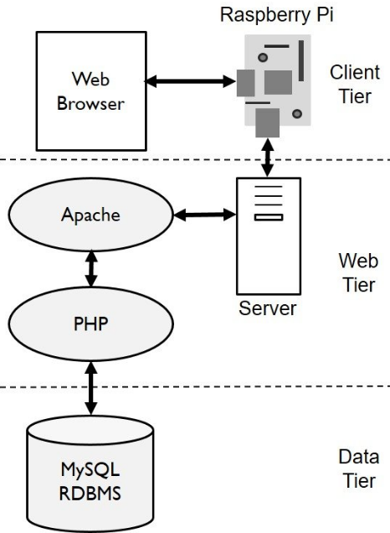

**THEORY EXERCISE: -Q) What is the significance of modularity in software architecture?**

=>Significance of modularity in software architecture are:

* Improved maintainability
* Reusability
* Scalability
* Enhanced collaboration
* Flexibility
* Adaptability

12>**LAB EXERCISE: -Create a case study on the functionality of the presentation, business logic, and data access layers of a given software system.**

### =>Presentation Layer

* Purpose: This layer is responsible for interacting with the end-user by providing an intuitive and responsive interface for the application.

2. Business Logic Layer

* Purpose: This layer processes user requests, applies business rules, and coordinates interactions between the Presentation and Data Access layers.

3. Data Access Layer

* Purpose: This layer manages the storage, retrieval, and manipulation of data in the database.

**THEORY EXERCISE: -Q) Why are layers important in software architecture?**

=>Layers are a crucial concept in software architecture.

-> Because they provide structure, separation of concerns, and facilitate maintainability, scalability, and flexibility in a system.

13>**LAB EXERCISE: -**: **Explore different types of software environments (development, testing, production).Set up a basic environment in a virtual machine.** 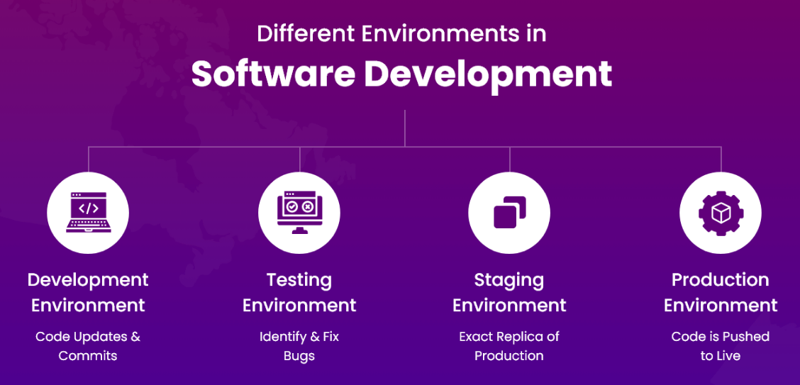

**THEORY EXERCISE: -Q) Explain the importance of a development environment in software production.**

=>A development environment is a critical part of the software production lifecycle. It provides a dedicated space for developers to write, test, and debug code before it moves to testing and production stages.

->A development environment is isolated from the testing and production environments, ensuring that changes and experiments do not disrupt the live system or other workflows.

->The development environment is vital because it enables developers to build, test, and debug software efficiently in an isolated, controlled, and safe space.

-> It ensures high-quality code transitions smoothly into subsequent stages of the software development lifecycle.

14> **THEORY EXERCISE: -Q) What is the difference between source code and machine code?**

=>Source code is the human-readable instructions written by a programmer in a high-level programming language whereas machine code is the binary instructions that are directly executed by a computer’s CPU.

->Source code is easy to modify whereas machine code is hard to modify.

->Source code is need to compile whereas machine code is directly executed by the CPU.

15>

**THEORY EXERCISE: -Q) Why is version control important in software development?**

=>Version control is essential in software development because it helps manage changes to code, fosters collaboration, and ensures project stability and traceability.

16>

**THEORY EXERCISE: -Q) What are the benefits of using Github for students?**

=>sing GitHub offers numerous benefits for students, especially those learning software development, collaborating on projects, or building a professional portfolio.

->GitHub makes it easy to collaborate on group assignments by allowing multiple contributors to work on the same project.

->Learn to use issues, pull requests, and project boards to manage workflows effectively.

17>LAB EXERCISE: - **Create a list of software you use regularly and classify them into the following categories: system, application, and utility software.**

System software:

Software that manages hardware and provides basic functionalities for application software.

* **Operating System**: Windows, macOS, Linux
* **Device Drivers:** Printer drivers, GPU drivers (e.g., NVIDIA, AMD)
* **Firmware:** BIOS, UEFI

Application software

Software that helps users perform specific tasks or functions.

* **Web Browsers:** Google Chrome, Mozilla Firefox, Microsoft Edge
* **Office Productivity Tools:** Microsoft Word, Excel, PowerPoint, Google Docs
* **Messaging Apps**: WhatsApp Desktop, Slack, Microsoft Teams
* **Media Players**: VLC Media Player, Spotify, YouTube App
* **Design and Editing Tools**: Adobe Photoshop, Canva, Figma
* **Social Media Apps**: Instagram, Twitter, LinkedIn

Unity software

Software that performs maintenance tasks and optimizes system performance.

* **Antivirus Software:** Norton, McAfee, Windows Defender
* **Disk Management Tools**: Cleaner, Disk Clean-up, Partition Magic
* **Backup Software:** Google Drive, One Drive, Dropbox

**THEORY EXERCISE: -Q) What are the differences between open-source and proprietary software?**

=>In open source code that is publicly available for use, modification, and distribution. Whereas in proprietary source code that is privately owned and not accessible to users.

->In open source generally its free to use whereas in proprietary source you have to pay to use it.

->In open source code that is privately owned and not accessible to users whereas in proprietary software Security relies on the vendor, and users must trust the company to patch vulnerabilities.

18>

**THEORY EXERCISE: -Q) How does GIT improve collaboration in a software development team?**

=>Git significantly improves collaboration in software development teams by enabling efficient version control, facilitating teamwork, and streamlining workflows.

->Git helps in:

* Distributed version control
* Branching and margin
* Conflict resolution
* Collaboration through pull request
* Change tracking and accountability

19>**LAB EXERCISE: -Write a report on the various types of application software and how they improve productivity.**

=>Application software refers to programs designed to help users perform specific tasks or functions. Unlike system software, which operates hardware, application software focuses on productivity, creativity, and utility. In this report, we explore various types of application software and how they contribute to enhancing productivity in personal, professional, and organizational contexts.

**THEORY EXERCISE: -Q) What is the role of application software in businesses?**

=>Application software plays a crucial role in businesses by enabling them to perform specific tasks, improve efficiency, and support their operational, strategic, and decision-making processes.

20>**LAB EXERCISE: -create a flowchart representing the software development life cycle (sdlc)**

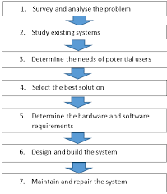

**THEORY EXERCISE: -Q) What are the main stages of the software development process?**

=>The software development process consists of several stages designed to ensure the efficient creation, delivery, and maintenance of high-quality software.

-> Understand the business needs and define the software's objectives and scope.

-> Create the blueprint for the software solution.

-> Build the software based on the design specifications.

-> Decommission the software when it's no longer needed.

21>**LAB EXERCISE: -** **Write a requirement specification for a simple library management system.**

**=>**1. Introduction

This document defines the functional and non-functional requirements for a Simple Library Management System.

2. Functional Requirements

1. User Management
2. Book Management
3. Loan Management

**Non-Functional Requirements**

**1. Usability**

**2. Performance**

**3. Security**

**. THEORY EXERCISE: -Q) Why is the requirement analysis phase critical in software development?**

**=>**The **requirement analysis** phase is critical in software development because it serves as the foundation for the entire project.

->Properly identifying, understanding, and documenting the requirements ensures that the final product meets user expectations, functions as intended, and is delivered on time and within budget.

22>**LAB EXERCISE: -**

**=>**User Account Management

Product Catalog

Shopping Cart Management

Checkout and Payment

**THEORY EXERCISE: -Q) What is the role of software analysis in the development process?**

**=>Software analysis** plays a critical role in the software development process as it helps ensure that the software will meet its intended purpose and function as expected.

->It focuses on understanding the problem domain, gathering requirements, and modelling the system to ensure that both technical and business needs are well-defined.

23>**LAB EXERCISE: -**

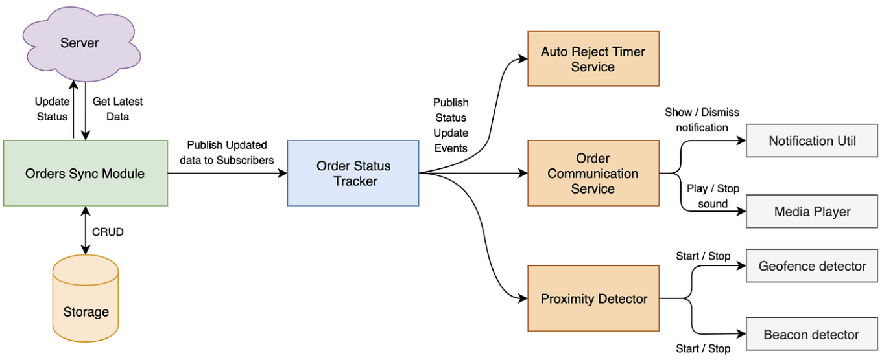

**THEORY EXERCISE: -Q) What are the key elements of system design?**

**=>**System design is a crucial phase in the software development process that defines the architecture and structure of the system.

->It involves translating the requirements and analysis into a blueprint that guides developers, engineers, and other stakeholders throughout the development.

->The key elements of system design are as follows:

* System architecture
* Data design
* UI Design
* Component design

24>**LAB EXERCISE: -**

Test Case: Addition Operation

* Test Case ID: TC001
* Test Description: Verify the addition of two positive numbers.
* Input:
  + Operand 1: 5
  + Operand 2: 3
  + Operation: Addition
* Expected Result:
  + Result: 8

Test Case: Subtraction Operation

* Test Case ID: TC002
* Test Description: Verify the subtraction of a smaller number from a larger number.
* Input:
  + Operand 1: 7
  + Operand 2: 4
  + Operation: Subtraction
* Expected Result:
  + Result: 3

**THEORY EXERCISE: -Q) Why is software testing important?**

**=>Software testing** is crucial in the software development process as it ensures that the software meets its requirements, performs as expected, and is free from defects.

->Testing plays a key role in delivering high-quality software that satisfies users, maintains security, and functions properly in various environments.

25>**LAB EXERCISE: -**

=>One real-world case of critical maintenance for a software application occurred with **Amazon Web Services**

**THEORY EXERCISE: -Q) What types of software maintenance are there?**

**=>**There are mainly 5 types of software maintenance:

* Corrective maintenance
* Adaptive maintenance
* Perfective maintenance
* Preventive maintenance
* Emergency maintenance

**26>THEORY EXERCISE: -Q)** **What are the key differences between web and desktop applications?**

=>The difference b/wweb and desktop applications:

* Webis accessible in web only whereas in desktop applications is installed directly on user device**.**
* In web no installation is required whereas in desktop application installation is required.

27>**THEORY EXERCISE: -Q) what are the advantages of using web applications over desktop applications?**

**=>**Web applications offer several advantages over desktop applications, especially in terms of :

* Accessibility
* Maintenance
* Saleability

28>**THEORY EXERCISE: -Q) what role does UI/UX design play in application development?**

=>Roles are:

* Enhances User Engagement
* Improves Usability
* Builds Brand Identity and Trust
* Reduces Development Costs and Time
* Enhances User Satisfaction
* Encourages User Retention
* Supports Scalability

29>**THEORY EXERCISE: -Q) what are the differences between native and hybrid mobile apps?**

**=>**Native mobile appsBuilt specifically for a particular platform whereas hybrid mobile apps built using web technologies like HTML, CSS, and JavaScript.

->Native mobile app Superior performance as they are optimized for a specific platform whereas hybrid mobile apps performance can be slower than native apps due to the additional layer between the app and the device hardware.

->native mobile apps more effort is needed to maintain separate codebases and roll out updates for each platform whereas hybrid mobile apps easier to maintain and update since changes are made in a single codebase.

30>**LAB EXERCISE: -**

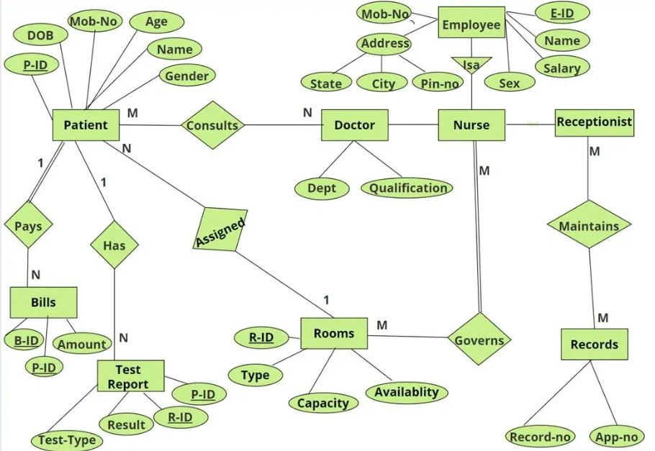

**THEORY EXERCISE: -Q) What is the significance of DFDs in system analysis?**

=>**Data Flow Diagrams** are essential tools in system analysis, offering a graphical representation of the flow of data within a system.

-> They illustrate how data moves between processes, data stores, and external entities, helping analysts, developers, and stakeholders better understand and communicate system functionality.

31>**LAB EXERCISE: -**

**=>need to work on it.**

**THEORY EXERCISE: -Q) What are the pros and cons of desktop applications compared to web applications?**

=>**Pros of Desktop Applications**

* Designed to run directly on the user's hardware, leading to faster and more efficient performance for resource-intensive tasks like gaming, video editing, and CAD.
* Better suited for applications requiring high processing power or access to system-level features.

->**Cons of Desktop Applications**

* Require separate versions for different operating systems, increasing development and maintenance costs.
* Expanding or upgrading desktop applications can be more complex compared to web applications, especially when distributing updates to a large user base.

=>**Pros of Web Applications**

* Accessible from any device with a browser and internet connection, providing flexibility and portability.
* Easier to scale for a growing user base or additional features, thanks to cloud-based infrastructure.

### -> Cons of Web Applications

* Require an active internet connection, which can limit usability in areas with poor connectivity.
* Centralized data storage and internet access increase vulnerability to cyber-attacks and data breaches.

32>**LAB EXERCISE:**

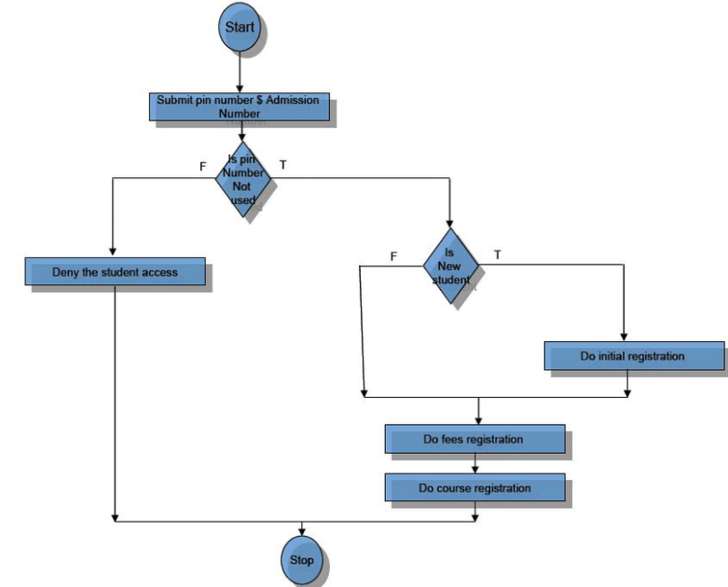

**THEORY EXERCISE: -Q) How do flowcharts help in programming and system design?**

=>Flowcharts are a vital tool in programming and system design as they provide a visual representation of processes, workflows, and decision-making paths

->They make complex systems easier to understand and are instrumental in planning, communication, and troubleshooting.